EAST 2012 Experimental Campaign Highlights
Institute of Plasma Physics, Chinese Academy of Sciences, Hefei, P. R. China
(July 10, 2012)

EAST undertook an extensive upgrade during the last shutdown in 2011, from Plasma Facing Components (PFC), poloidal field (PF) power supply, and auxiliary heating to many key diagnostic systems. With the advent of significantly augmented auxiliary heating, operation and diagnostic capabilities, EAST has carried out an extensive experimental campaign since Spring 2012, aiming at exploring the boundary of the EAST operation space with favorable stability and confinement and developing suitable means to expand this space toward steady-state operation. To these ends, the campaign has focused on ICRH and LHCD physics, MHD and ELM control, L-H transition and pedestal physics, divertor physics and emerging PSI issues under long pulse operation conditions, and developing advanced scenarios that integrate high performance with long pulse operations. EAST 2012 campaign has been accomplished on July 10th.
Significant progress has been made on EAST during this new experimental campaign on many physics and technology fronts, with the following key advances:
- Achieved long pulse H-modes over 30 s with LHCD and ICRH, facilitated by active lithium (Li) and cryopumping.
- Achieved long pulse divertor plasma up to 411s, which was fully driven by LHCD with active-cooled PFC and internal cryopump.
- Achieved a long-pulse Enhanced $D_{α}$(EDA) H-mode regime and further verified the role of zonal flows in the L-H transition by direct gas dynamic imaging.
- Demonstrated change in edge magnetic topology induced by LHCD, which have potentially significant impacts on divertor and edge physics, such as power deposition, edge rotation and L-H transition, etc.
- Observed a lower L-H transition power threshold for the ion $B×∇B$ drift direction away from the dominant divertor in the RF heated discharges in EAST, opposite to the previous observations in other tokamak.
- Upgraded RF and LH systems to a total power of 8 MW, implemented more than 10 new diagnostics, and developed a new CW pellet injection system and supersonic molecule beam injection (SMBI) system for ELM mitigation and precise density feedback control.
- Successfully demonstrated ELM control by LHW power modulation, SMBI, D₂ pellet and innovative Li pellet injection.
In order to facilitate long pulse operations, half of carbon tiles on the wall and divertor surfaces were replaced with molybdenum tiles during the last EAST shutdown, allowing baking up to 250 °C. In addition, the Li evaporation system was upgraded to improve coating uniformity. This, along with enhanced wall baking capability and active divertor pumping, greatly facilitates recycling control. Reproducible, 32 s long pule H-modes have been achieved in EAST driven by LHCD, assisted by ICRH. Figure 1 shows a typical long pulse H-mode plasma discharge in EAST obtained under the double null (DN) divertor configuration. This particular discharge exhibits type-III like small ELMs with H_{98,y2} ~ 0.9, due to marginal auxiliary heating, with combined LHCD and ICRH input power about 2.5 MW. Stationary type-I like ELMy H-modes with higher confinement quality have also been obtained in EAST by further increasing RF heating.
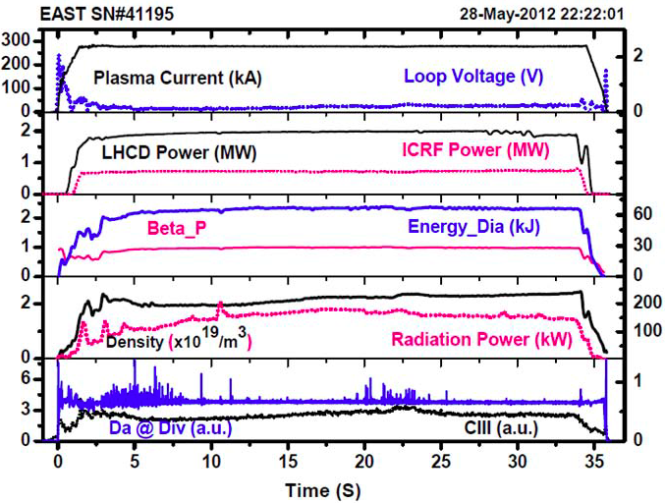
FIG. 1. Long pulse H-mode discharge recently achieved in EAST with combined LHCD and ICRH.
Over 400s long pulse steady-state divertor discharge (Fig. 2) has been realized with the line average density being maintained at ~1.5x10¹⁹ m⁻³ and temperature close to 2keV, and all the plasma parameters, including wall temperature, reaching a truly stead-state condition. This has been achieved using the following key approaches: (1) All PFCs have been actively cooled, with internal cryopump activating; (2) Real-time plasma control has been applied to maintain plasma shape, density and effective coupling for LHW; (3) Strike point sweeping and varying plasma configuration from USN to DN and LSN have been applied during the discharge for minimizing divertor heat load, impurity influxes and plasma wall interactions under the steady-state condition; (4) Further, one key issue is to keep all PF coil currents at a minimum level (<2kA), well below the critical current limit (14.5kA) to maintain a large safe operation margin for superconducting coils, which is crucial for future ITER long pulse (400s) operations.
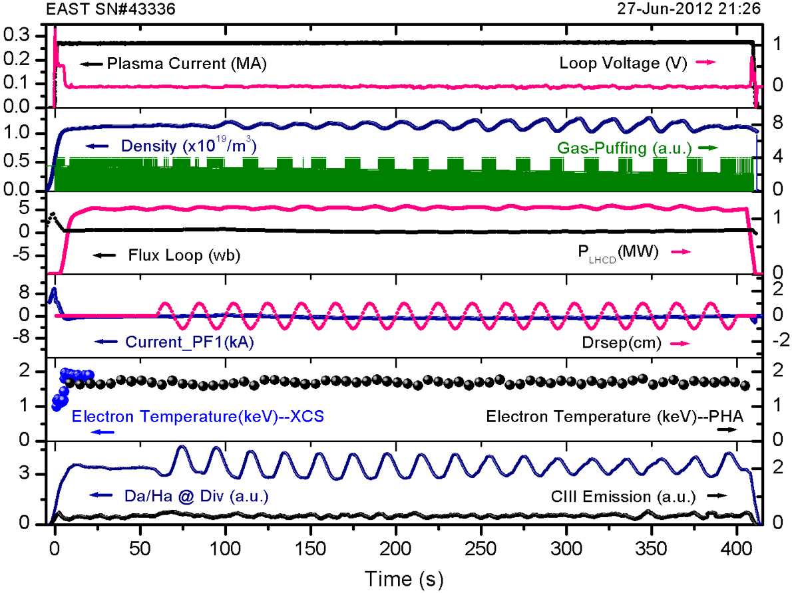
FIG. 2. 411s discharge by LHCD, T_{e} = 1.8 keV, B_{t} = 2.0 T.
It is remarkable that the access to H-modes in EAST exhibits a lower power threshold for the ion $B×∇B$ drift away from the dominant X-point, in striking contrast to other tokamaks or STs. EAST has identical top and bottom divertor geometry with a flexible poloidal field control system to enable operations with both single null and double null divertor configurations. This greatly facilitates the assessment of the access to H-mode with respect to the ion ∇B drift direction by simply changing the divertor configuration between lower single null (LSN) and upper single null (USN) configurations during the same discharge. For normal B_{T}, it requires lower LHCD or LHCD+ICRH power to access the H-mode with USN, i.e., with the ion ∇B drift away from the dominant divertor, while LSN is favorable for reversed B_{T}, opposite to the observations in other tokamak or ST experiments with dominant NB heating. This may have significant implications for ITER, which only accommodates the LSN configuration with dominant electron heating.
LHCD appears to induce a profound change in the edge magnetic topology by driving currents in the edge plasma, as evidenced by the non-rotating Helical Current Filaments (HCFs) flowing along the magnetic field lines in the SOL, Fig. 3. This leads to the splitting of divertor strike points (SP) with similar effects to the resonance magnetic perturbations (RMPs), as manifested in heat and particle flux profiles. The change in edge topology has been qualitatively modeled by including the HCFs (Fig. 3). The 3D edge topology induced by LHCD can be actively controlled by adjusting the plasma edge safety factor and LHCD power.
Different techniques have been explored for ELM control during this campaign, including modulating LHW power, SMBI, injection of Li and D₂ pellets. Effective ELM mitigation has been achieved by LHW power modulation and SMBI. In addition, ELM pacing has been successfully achieved with D₂ pellet injection from both high field side (HFS) and low field side (LFS). Furthermore, ELM pacing has also been demonstrated, for the first time in EAST, using the innovative Li-pellet injection technique (Fig. 4).
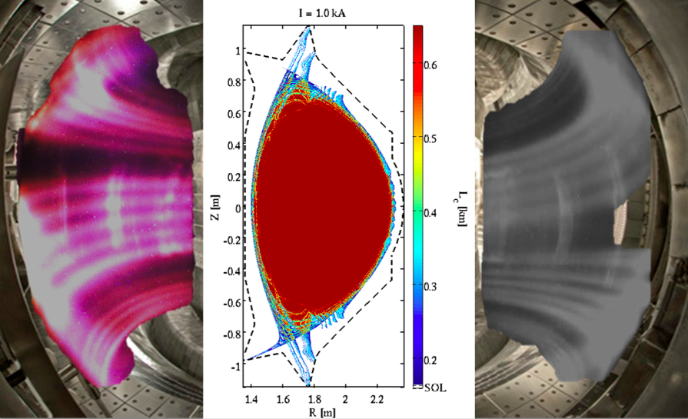
FIG. 3. Non-rotating helical radiating belts induced by LHCD in the plasma edge, seen by two visible cameras viewing different sides of the EAST torus (left and right); Contour of connection length of the poloidal cross-section at 𝜑 = 0∘ for shot #29100 at 3.5s with modeled HCFs (middle).

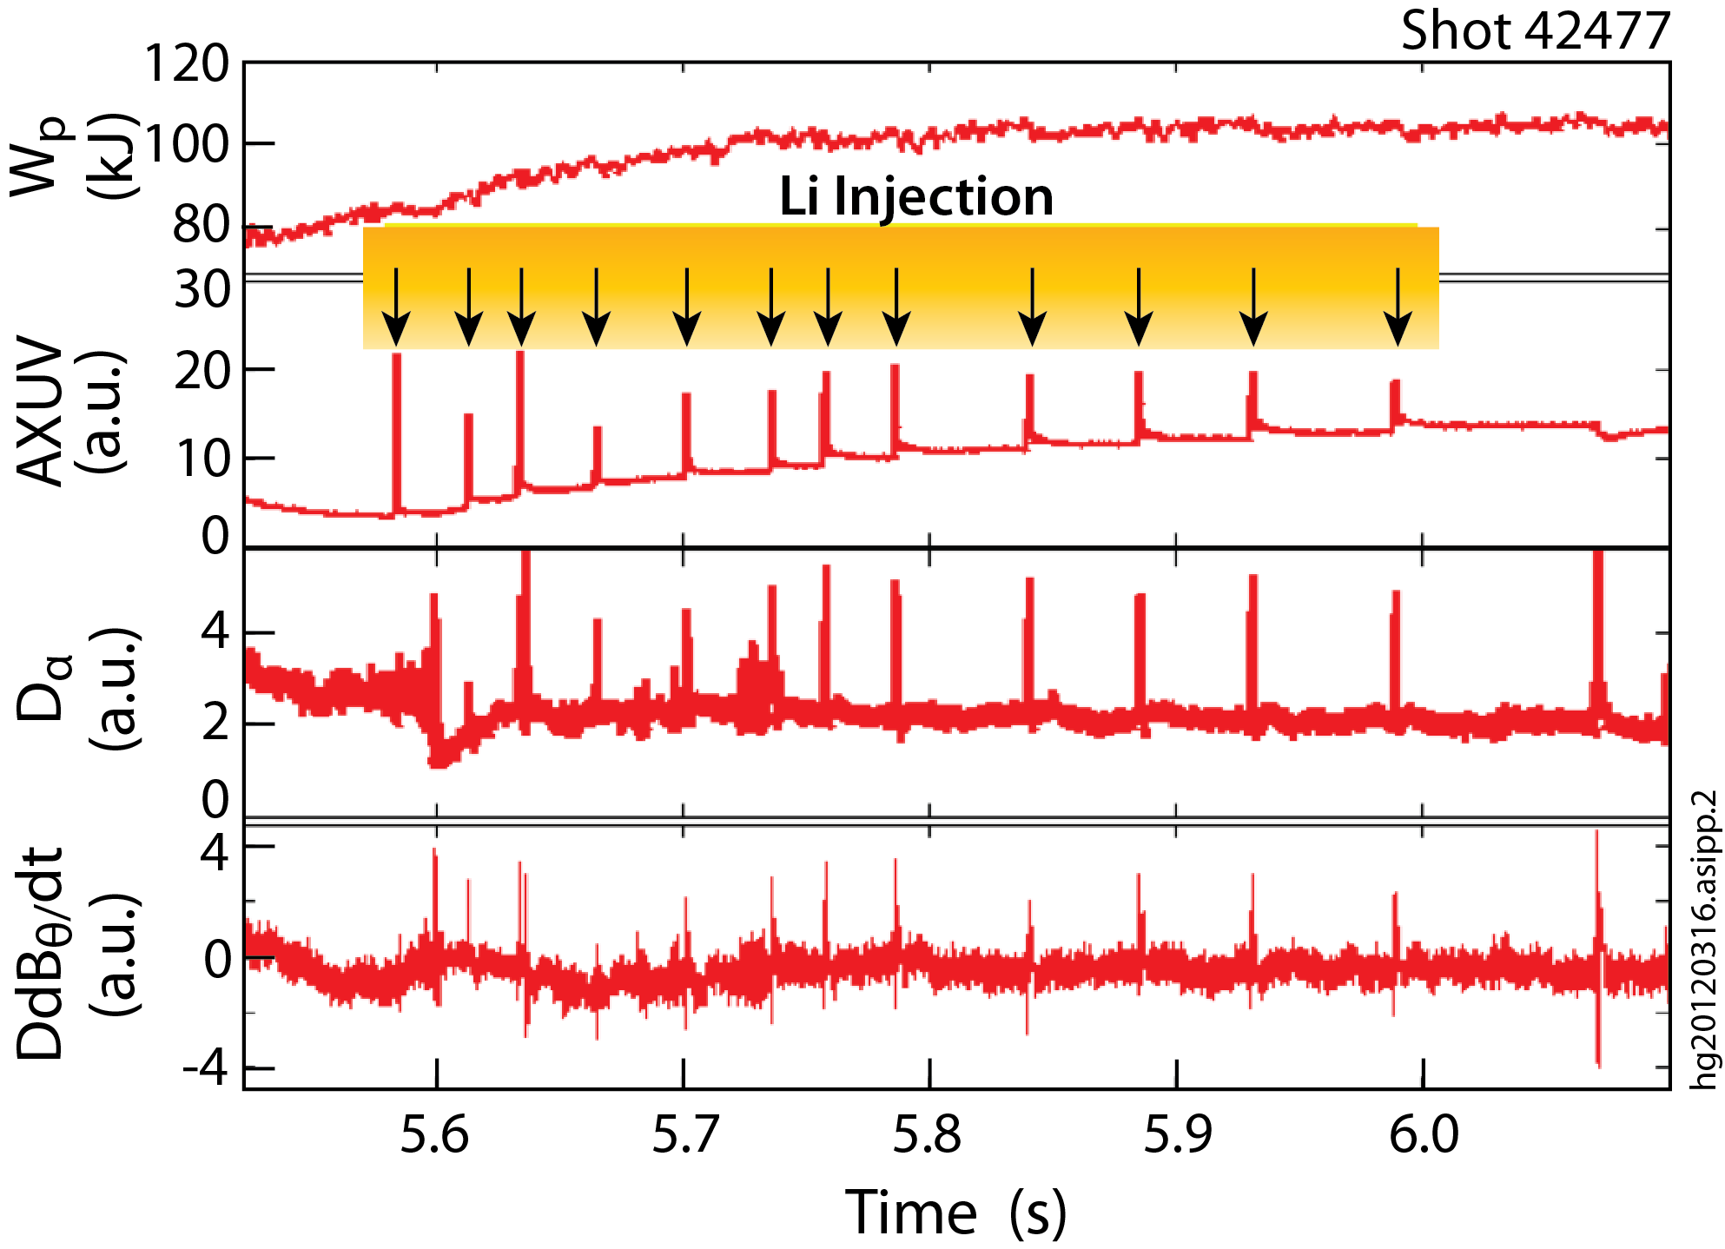
FIG. 4. ELM pacing in EAST using the new Li-injection technique with the pellet size of 0.7 mm at 45 m/s. Each pellet triggers an ELM during ELM free phase after the L-H transition.
In summary, EAST has started to demonstrate its long pulse operation capability with improved PFCs, active Li and cryopuming, together with new control tools such as SMBI, low/high field side pellet injection, and Li-pellet injection. This has enabled study of new H-mode physics in RF dominated regimes and issues related to long pulse operations. The EAST 2013 experimental campaign is foreseen for fall 2013 with more than 20MW CW H&CD and ITER-like W mono-block divertor, which will certainly produce more exciting results. International contributions from USA (GA, PPPL, MIT, UCSD, ORNL), France (CEA), Japan (NIFS, JAEA), Korea (NFRI), Germany (IPP, FZJ) and ITER IO are one of the key ingredients for these achievements, and are much appreciated.

